Low Level Design (LOGIN module)

Project Code | Team2
Project Name | Online Recruitment Management System

Prepared/Modified by | Role | Date of Preparation
Akash Bansal | Senior Software Analyst | 11/11/2017
Reviewed by | Role | Date of Review
Vaishali Srivastava | Consultant | 16/11/2017
Approved by | Role | Date of Approval
Vishal Mali | Senior Consultant
Circulation List | akash.bansal@capgemini.com,  mvallamk@capgemini.com,  kaustav.saha@capgemini.com,  mohit.deshmukh@capgemini.com | Version Number of the template:1.0
Version Number | 1.3

Table of Contents

1. Description Of The Unit 3
2. References 4
3. Dependencies / Assumptions 5
4. Class Diagrams 6
5. Sequence Diagrams 7
6. Design Components 8
6.1 List Of UI Components 8
6.2 List Of Design Classes 8
7. Re-Usable Routines/Components 9
8. Messages 10
9. Configuration Files 11
10. Crud Matrix Table 12
11. Data Mapping Matrix 13
12. Action Flow Matrix 14
13. Stored Procedures 15
14. Program Specification / Pseudo Code 16
REVISION HISTORY OF THE WORK PRODUCT 17

Description Of The Unit

The login module allows the users to log into the online portal. This can be done by any user having username and password.

On clicking the login button, user will be redirected to the Login page where the user has to enter username and password. The entered username will be matched in the database ,if exists, will validate the password entered by user with that existing in the database for the respective username.
If matched, the user type is taken from the database ( User, Company, Admin) and will be redirected to the page containing the operation allowed for the specific user type. If the type is User, then the User will be redirected to page providing options like add resume, update resume etc.
If not matched, user will be redirected to the same login page with “Invalid Login Details” error shown on the page.

References

Reference | Description
Repository reference | https://IGTEBLRSVNTNG.igatecorp.com/svn/oct3_Team1
Class Diagram | /Project Documents/Design Documents/HLD/Class Diagrams
URS | /Project Documents/Requirements/Case Study/Ecommerce-grp1 and grp3.doc
UTP | /Project Documents/Test Plan/UTP/Test Cases/AddProduct /UTP_AddProductModule.xlsm
DB Design | /Project Documents/Design Documents/HLD/DB Design/E-Commerce_GROUP_DBDESIGN.xls

Dependencies / Assumptions

Dependencies:
This module is dependent on the registration module wherein the user details are taken and stored in the database.

Assumptions:
The login details are already present in the database.

Class Diagrams

Class Diagram

Sequence Diagrams

Sequence Diagram
NA

Design Components

List Of UI Components
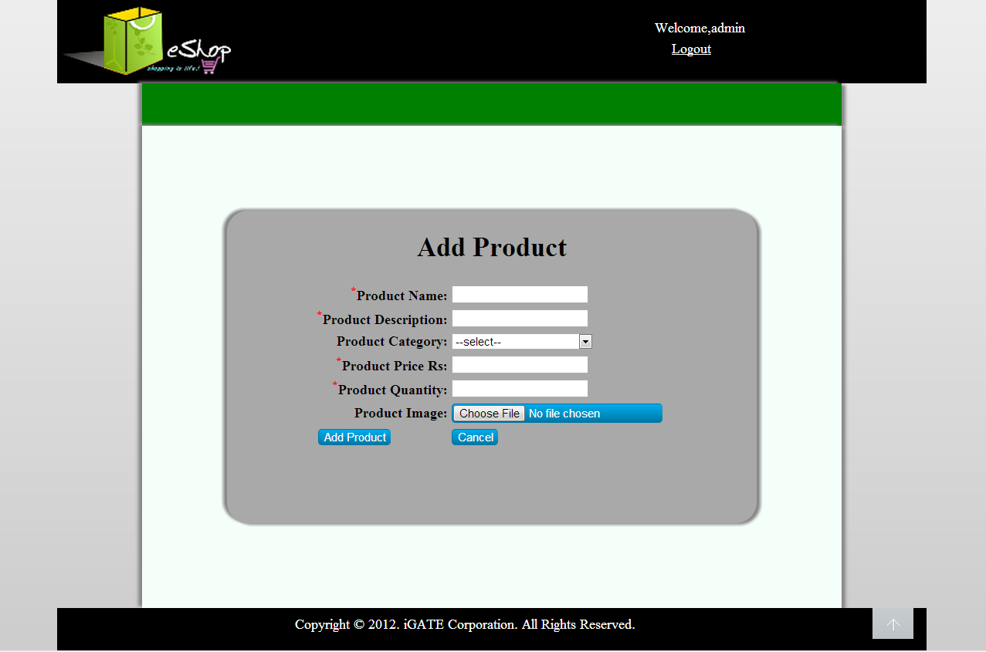

List Of Design Classes
Sr. No. | LLD Name | Class Name | Method Name | Method Description
1 | Login Module | Login | Appropriate getters and setters methods | Getters retrieve the property values and setters set the property values
2 | Login Module | RecruitmentController | showLoginPage(Model model):String  login(@RequestParam("loginid") String login,@RequestParam("password") String password ,Model model):String | Sets the model attribute.  Calls validateLoginDetails() of RecruitmentServiceImpl class. If it returns true, then it will call getLoginDetails() of RecruitmentSeviceImpl class and show the respective operation form based on the user type.  If validateLoginDetails() return false, then it will redirect back to login page with error message.
3 | Login Module | RecruitmentServiceImpl | validateLoginDetails(String,String):Boolean  getLoginDetails(String):Login | Calls getLoginDetails() of RecruitmentDAOImpl class and validate username and password taken from the database with the values taken by user and return Boolean to the controller.  Calls getLoginDetails() of RecruitmentDAOImpl class and return the Login object to controller.
4 | Login Module | RecruitmentDAOImpl | getLoginDetails(String):Login | Retrieves the login details from the database having respective login id.

Re-Usable Routines/Components

Re-Usable Routines/Components

- CSS files
- DataAccessException class
- Database xml files
- Logger properties files

Messages

#. | Type | Message Text
M1 | Error | Invalid Login Details

Configuration Files

File Name | Path | Description
jpaContext.xml | /Development/Source/OnlineRecruitmentSystem/resources | To configure database connection.
web.xml | /Development/Source/OnlineRecruitmentSystem/WebContent/WEB-INF | To configure the bean properties and request mapping.
servlet-config.xml | /Development/Source/OnlineRecruitmentSystem/WebContent/WEB-INF/config | To configure view resolver.
log4j.properties | /Development/Source/OnlineRecruitmentSystem/resources | To configure the logger.

Crud Matrix Table

# | Table Name | Create | Read | Update | Delete
1. | Login | N | Y | N | N

Data Mapping Matrix

Sr. No. | Screen Label | Field Source | Field Type | Data Type | Max Length | Data Flow | Mandatory
1 | UserName | NA | Label | NA | NA | UI | NA
2 | txtUserName | Login.userName | TextBox | Varchar2 | 16 | UI | Yes
3 | Password | NA | Label | NA | NA | UI | NA
4 | txtPassword | Login.password | TextBox | Varchar2 | 16 | UI | Yes
14 | Login | NA | Button | NA | NA | UI | NA

Legend
D → UI (Database to User Interface)
UI → D (User Interface to Database)
UI (User Interface Only)

Action Flow Matrix

Sr. No. | Action | Description | Process
1 | On click of Login Button on Home page | Redirected to the Login page | The admin clicks on the Login button in the homepage and gets redirected to the login page.
2 | On click of login button on Login Page | After validation, redirects to operation list on the basis of type of user. | Data is entered in the fields by the user which gets validated. If correct, user will be redirected to its respective operation page.

Stored Procedures

# | Stored Procedure Name  (with Description) | Input/Out Parameters | Type | Size
1. | NA | NA | NA | NA

Program Specification / Pseudo Code

<ACTION :ADD_CLICK >

Pseudo Code:
- Client Side Scripting:
None

- Server Side Scripting:
BEGIN
Call prepareAdd(Model model) in Controller class
Navigate to add page
END

14. 2 <ACTION: ADDPRODUCT_CLICK>

Pseudo Code:

- Client Side Scripting:

IF invalid ProductName
Print Error Message M1
IF ProductName isEmpty
Print Error Message M6
IF invalid ProductDescription
Print Error Message M2
IF ProductDescription isEmpty
Print Error Message M6
IF ProductSubCategory isEmpty
Print Error Message M3

IF invalid ProductPrice
Print Error Message M4
IF ProductPrice isEmpty
Print Error Message M6
IF invalid ProductQuantity
Print Error Message M5
IF ProductQuantity isEmpty
Print Error Message M6
IF ProductImage isEmpty
Print Error Message M6

- Server Side Scripting:
BEGIN
Call processAddPage(@RequestParam("file") String filename,@ModelAttribute("Product") @Valid Product product,BindingResult result,Model model) in Controller class in Presentation Layer
BEGIN
Call addProduct (Product product) in EshopBOImpl class in Service Layer
BEGIN
Call Call addProduct (Product product) in EshopDAOImpl class class in Data Access Layer
BEGIN
Create query for insert records into Product and Product_Image table
Return Integer value.
END
Return Integer value. to Service Layer
END
Return Integer value to Presentation Layer

END
IF successful navigate to home page
Else navigate to add page and show error.
END

14. 2 <ACTION: CANCEL_CLICK>

Pseudo Code:
1. Client Side Scripting:
None

2. Server Side Scripting:
BEGIN
Call prepareHomePage(Model model) in Controller class
Navigate to home page
END

REVISION HISTORY OF THE WORK PRODUCT

# | Date | Version # | Section Changed | Details of changes made | Approved By
1 | 16/12/2013 | 1.0 | LLD prepared | N/A | Uma M Ponniamman
2 | 17/12/2013 | 1.1 | Reusable components,  Pseudo code | Reusable components added.  The pseudo code is modified as per the specified flow. | Uma M Ponniamman
3 | 18/12/2013 | 1.2 | Reusable components,  References,  Data Mapping Matrix. | Reusable Components added.  File name with relative path is added in the references section.  The name of text boxes(screen label is changed). | Uma M Ponniamman
4 | 24/12/2013 | 1.3 | Configuration files,UI Components | Paths of the configuration files is updated and UI components(Screen Shots) added. | Uma M Ponniamman

